Name : Vishal Jha

Batch : Data Engineering

Date : 02-02-2024

Topic : Python Coding Challenge (Q1. Pandas)

Q1. Explain Pandas for Data Processing & execute Reading CSV Data using Pandas &Read Data from CSV Files to Pandas Dataframes &Filter Data in Pandas Dataframe using query.

Pandas is a popular open-source data manipulation and analysis library for Python. It provides data structures like Series and DataFrame, along with a variety of functions to efficiently manipulate, filter, and analyze data. Here's an explanation of how to use Pandas for data processing and an example of reading CSV data, creating a DataFrame, and filtering data using the query method.

1. Installing Pandas :



1. Importing Pandas:



1. Reading CSV Data : Assuming you have a CSV file named example.csv with the following data.

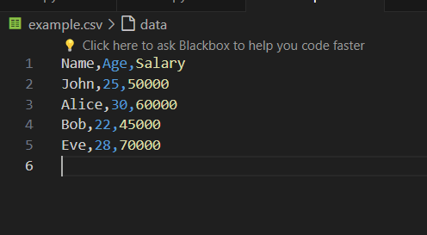

1. You can read this data into a Pandas DataFrame using the pd.read_csv() function:

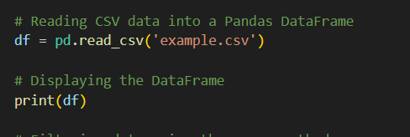

Output :

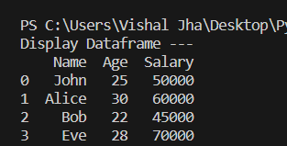

1. Filtering Data Using Query : You can use the query method to filter data based on specific conditions. For example, let's filter the data to only include individuals with a salary greater than 50000.

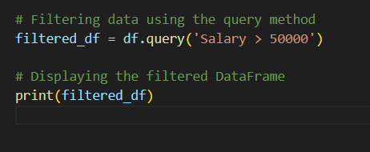

Output :

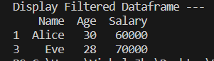

1. Complete Code :

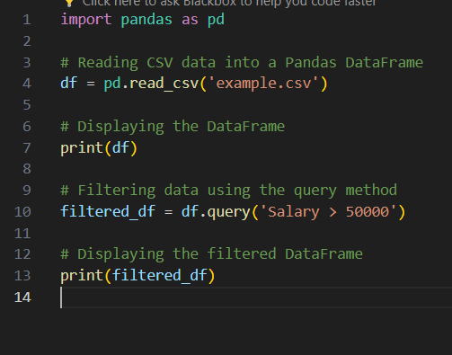

1. Output :

